**AI ASSISTED CODING**

**Lab-14.5**

**NAME:**K.SRIKAR

**ROLL NO:**2503A51L03(B19)

**Task 1: AI-Assisted Portfolio Website**  
Scenario:  
A student wants to showcase their projects, skills, and contact details in  
a portfolio website. Instead of writing all code manually, they want to  
speed up the process using GitHub Copilot.  
• Use Copilot to generate an HTML structure for a personal  
portfolio page (sections: Home, About, Projects, Contact).  
• Ask Copilot to suggest responsive CSS styling for the layout  
(e.g., grid/flexbox).  
• Customize Copilot’s suggestions to add a hover effect on project  
cards

**PROMPT:**

generate an HTML structure for a personal portfolio page (sections: Home, About, Projects, Contact).suggest responsive CSS styling for the layout (e.g., grid/flexbox).

add a hover effect on project cards give html css in same file

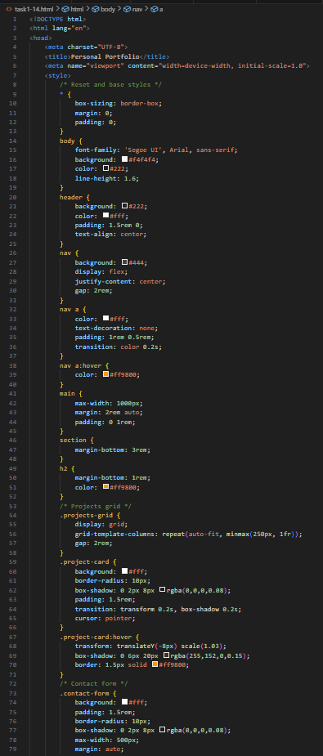

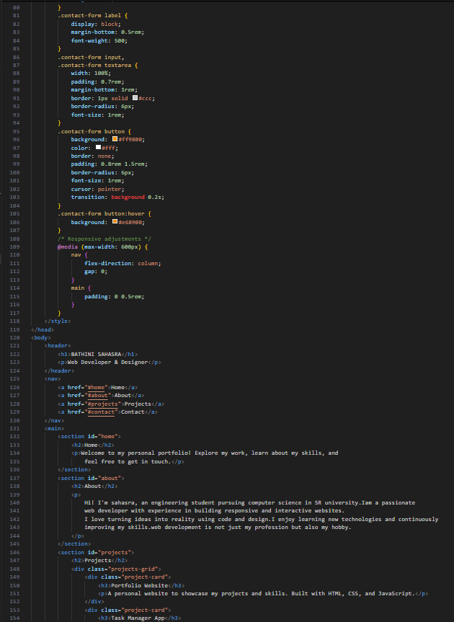

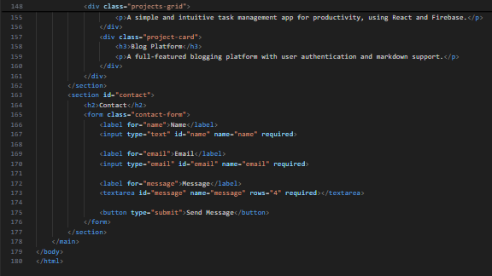

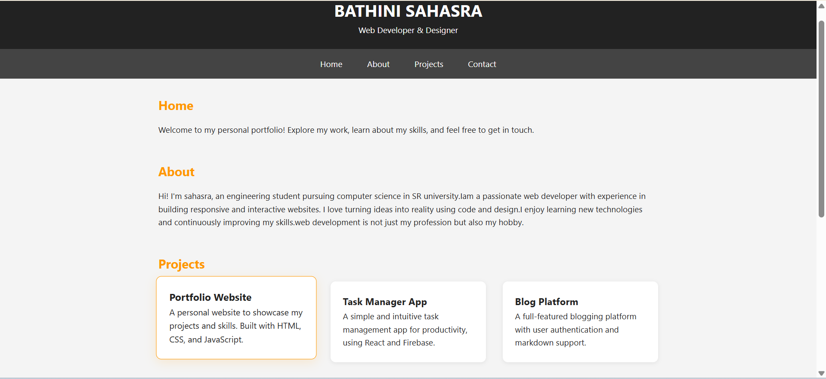

**OBSERVATION:**

The code builds a **responsive personal portfolio webpage** with four main sections: Home, About, Projects, and Contact. It uses **flexbox and CSS grid** for layout, ensuring adaptability across screen sizes. The navigation is sticky, the project cards include a **hover effect** (lift + shadow), and a simple contact form is provided, making the design clean, modern, and user-friendly.

**Task 2: AI-Generated Restaurant Landing Page**Scenario:  
A local restaurant needs a simple landing page with a navigation bar,  
menu highlights, and an image gallery. The developer wants to quickly  
generate it using AI assistance.  
• Use Copilot to create a navigation bar with links (Home, Menu,Gallery, Contact).  
• Generate a menu section styled with CSS cards.  
• Add a JavaScript-based image slider for the gallery, with  
Copilot suggesting the base code

**PROMPT:**

a local restaurant needs a simple landing page with a navigation bar,

menu highlights, and an image gallery.

•create a navigation bar with links (home, menu,

gallery, contact).

• generate a menu section styled with css cards.

• add a javascript-based image slider for the gallery, give all three codes in a single file

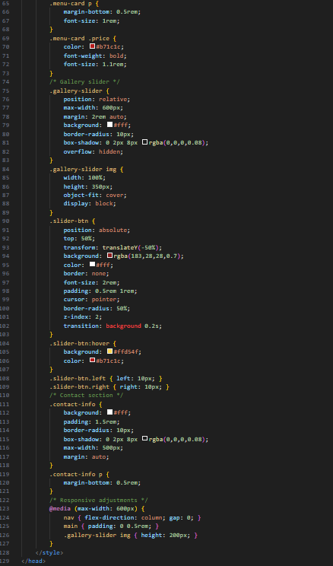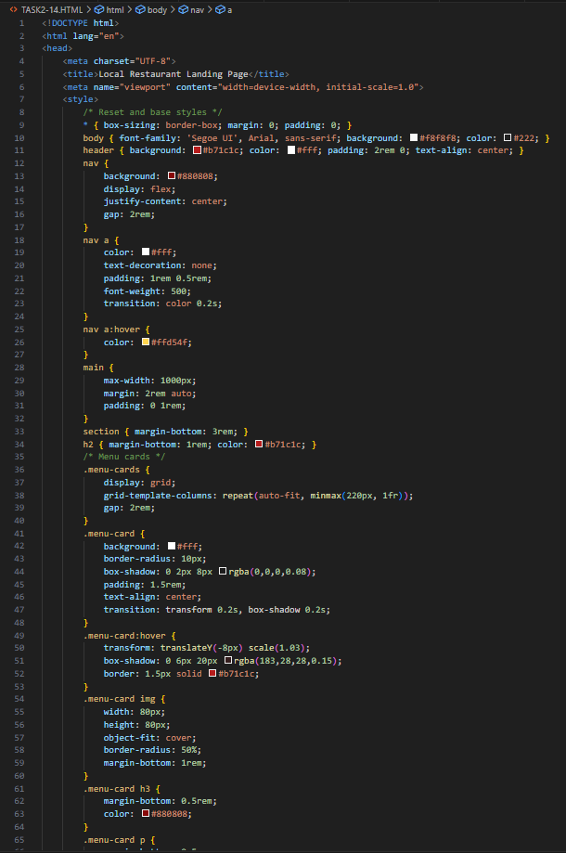

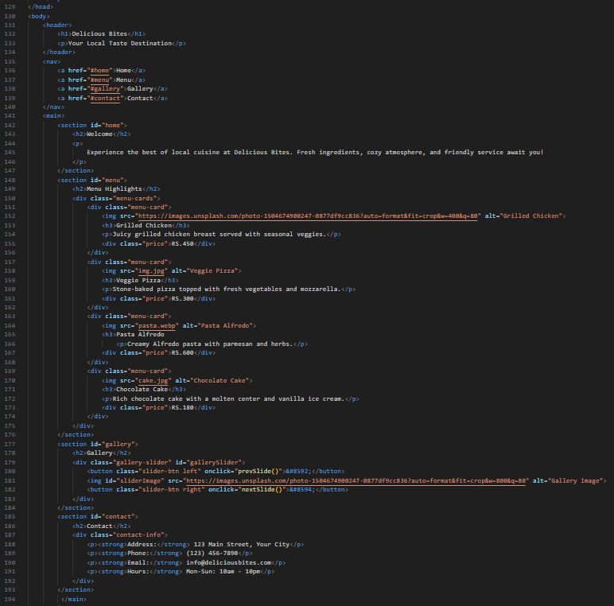

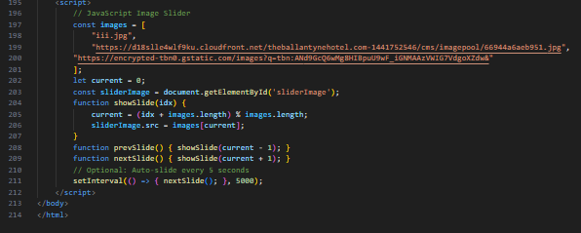

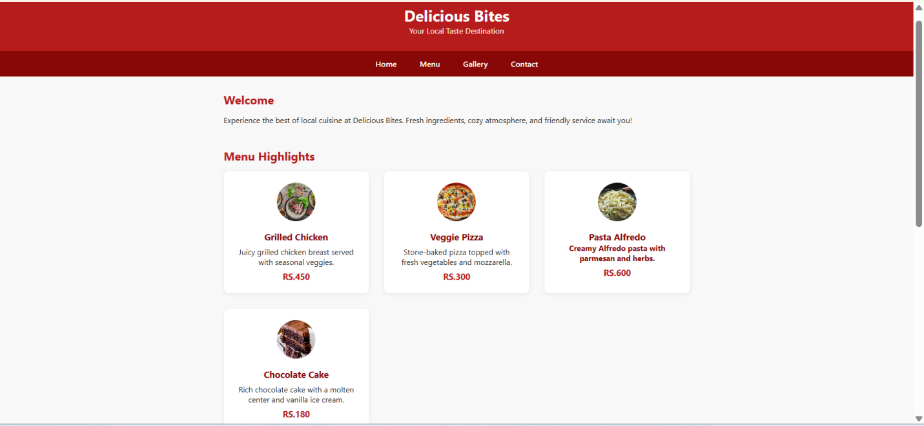

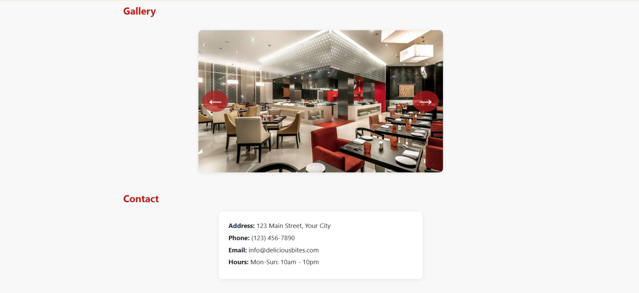

**Observation:**

The code designs a **simple and responsive restaurant landing page** with a sticky navigation bar, a menu section styled using CSS cards, and an interactive **JavaScript-based image slider** for the gallery. The layout is clean, user-friendly, and effectively highlights the restaurant’s offerings while ensuring easy navigation.

**Task 3: AI-Powered Event Registration Form**Scenario:  
SR University is hosting a tech fest. They need a web-based registration  
form for students. The form must validate user input in real-time.  
• Ask Copilot to generate an HTML form (fields: Name, Email,  
Phone, Department, Event Selection).  
• Use Copilot to assist in adding CSS styling for an attractive form  
layout.  
• Implement JavaScript validation (e.g., email format check,  
phone number length check) using Copilot’s suggestions.

**PROMPT:**

SR University is hosting a tech fest. They need a web-based registration

form for students. The form must validate user input in real-time.

• generate an HTML form (fields: Name, Email,

Phone, Department, Event Selection).

• assist in adding CSS styling for an attractive form

layout.

• Implement JavaScript validation (e.g., email format check,

phone number length check) using Copilot’s suggestions. Give js html css in single file

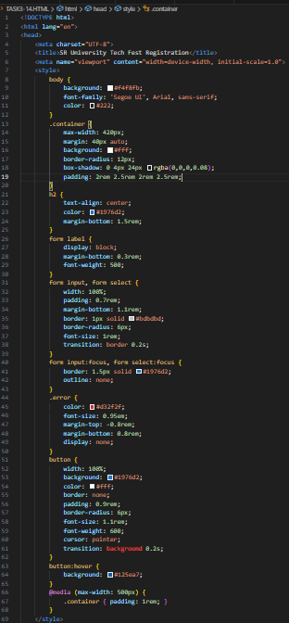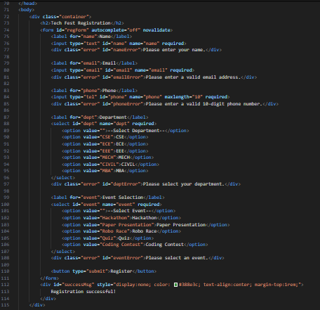

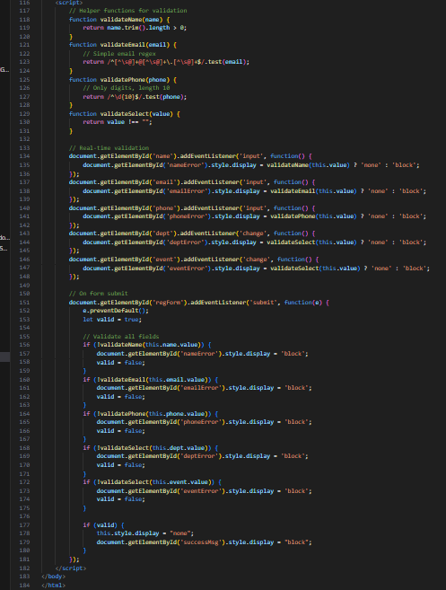

**OUTPUT:**



**Observation:**

The code provides a **modern, responsive registration form** with fields for student details and event selection. It uses **CSS for an attractive layout** and **JavaScript for real-time validation** (checking email format, phone length, and required fields). Error messages are displayed instantly, and a success message confirms registration, making the form both user-friendly and reliable.

**Task 4: AI-Assisted E-Commerce Product Page  
Scenario**:  
A startup wants a basic e-commerce product page to display products  
with prices and an “Add to Cart” button.  
• Use Copilot to generate a grid-based product catalog in  
HTML/CSS.  
• Implement a JavaScript “Add to Cart” functionality with  
Copilot’s guidance.  
• Modify Copilot’s suggestions to include a cart counter at the  
top-right corner of the page.

**PROMPT:**

A startup wants a basic e-commerce product page to display products

with prices and an “Add to Cart” button.

• generatea grid-based product catalog in HTML/CSS.

• Implement a JavaScript “Add to Cart” functionality

• include a cart counter at the top-right corner of the page. givehtml,css and js in the same file

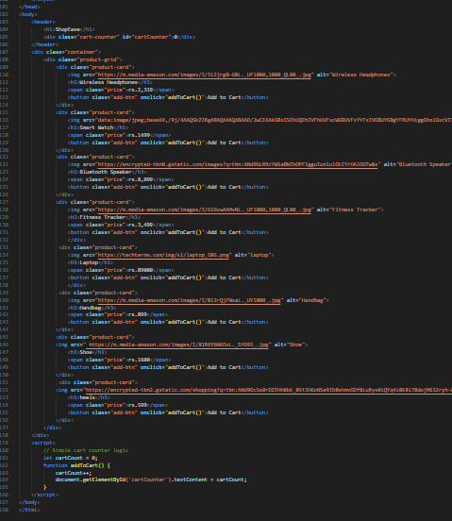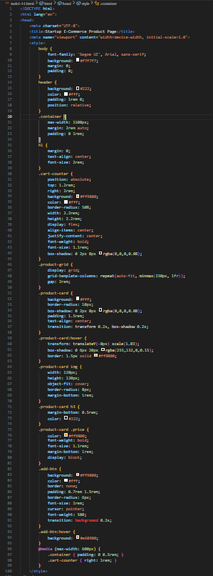

**OUTPUT:**

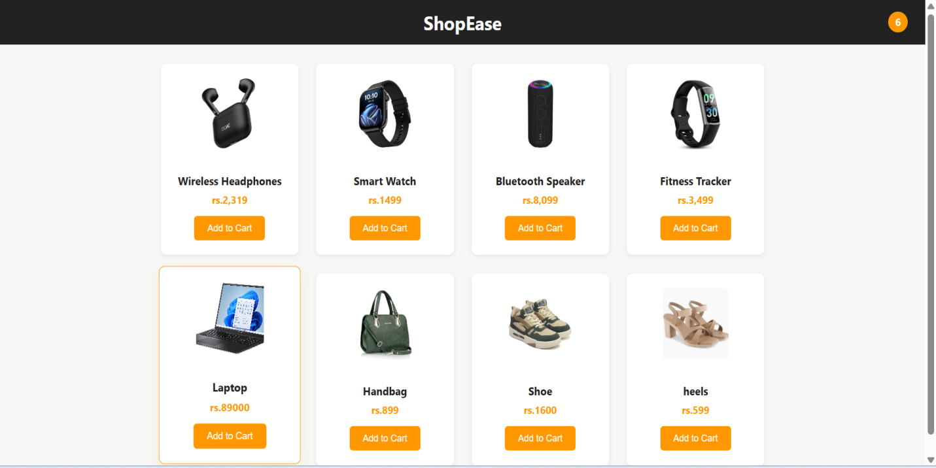

**OBSERVATION:**

The code creates a **basic e-commerce product page** using HTML, CSS, and JavaScript in a single file. It displays products in a **responsive grid layout** with images, names, prices, and an **“Add to Cart”** button. A **cart counter** is placed at the top-right corner inside the header and dynamically updates whenever the user clicks “Add to Cart.” The implementation is simple, lightweight, and serves as a starting point for building a full shopping cart system.